**Week 3: Network protocols and configurations**

**Task 1:**

Configure IP addresses manually for a network in Packet Tracer (Static).

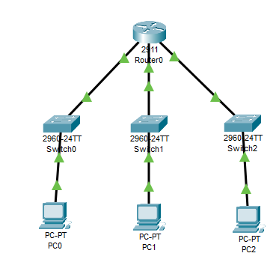

**Configuration :**

Router#

Router#

Router#sh ip interface brief

Interface IP-Address OK? Method Status Protocol

GigabitEthernet0/0 192.168.10.1 YES manual up up

GigabitEthernet0/1 192.168.20.1 YES manual up up

GigabitEthernet0/2 192.168.30.1 YES manual up up

Vlan1 unassigned YES unset administratively down down

Router#

Router#

Router#

Router#show ip route

Codes: L - local, C - connected, S - static, R - RIP, M - mobile, B - BGP

D - EIGRP, EX - EIGRP external, O - OSPF, IA - OSPF inter area

N1 - OSPF NSSA external type 1, N2 - OSPF NSSA external type 2

E1 - OSPF external type 1, E2 - OSPF external type 2, E - EGP

i - IS-IS, L1 - IS-IS level-1, L2 - IS-IS level-2, ia - IS-IS inter area

* - candidate default, U - per-user static route, o - ODR

P - periodic downloaded static route

Gateway of last resort is not set

192.168.10.0/24 is variably subnetted, 2 subnets, 2 masks

C 192.168.10.0/24 is directly connected, GigabitEthernet0/0

L 192.168.10.1/32 is directly connected, GigabitEthernet0/0

192.168.20.0/24 is variably subnetted, 2 subnets, 2 masks

C 192.168.20.0/24 is directly connected, GigabitEthernet0/1

L 192.168.20.1/32 is directly connected, GigabitEthernet0/1

192.168.30.0/24 is variably subnetted, 2 subnets, 2 masks

C 192.168.30.0/24 is directly connected, GigabitEthernet0/2

L 192.168.30.1/32 is directly connected, GigabitEthernet0/2

Router#

**Results:**

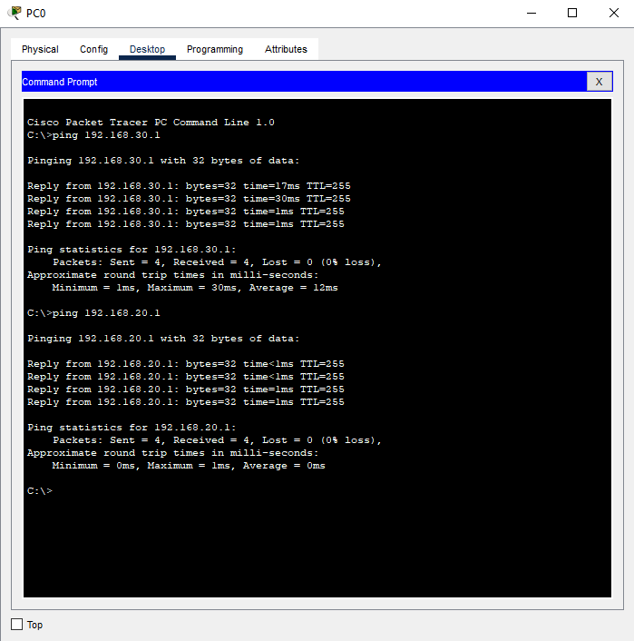

**Task 2:**

Enable DHCP on a router and test connectivity with DHCP clients.

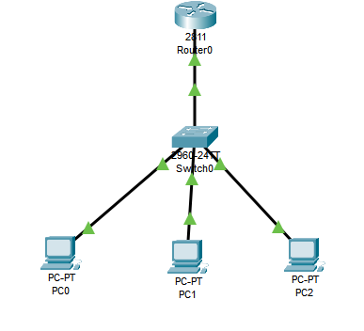

Router(config-if)#

Router(config-if)#exit

Router(config)#interface FastEthernet0/0

Router(config-if)#no ip address

Router(config-if)#ip address 192.168.50.1 255.255.255.0

Router(config-if)#ip address 192.168.50.1 255.255.255.0

Router(config-if)#

Router(config-if)#^Z

Router#

%SYS-5-CONFIG_I: Configured from console by console

Router#en

Router#config t

Enter configuration commands, one per line. End with CNTL/Z.

Router(config)#ip dhcp pool lan

Router(dhcp-config)#network 192.168.50.1 255.255.255.0

Router(dhcp-config)#default-router 192.168.50.1

Router(dhcp-config)#dns-server 8.8.8.8

Router(dhcp-config)#ex

Router(config)#ip dhcp excluded-address 192.168.50.1 192.168.50.9

Router(config)#

PC0:

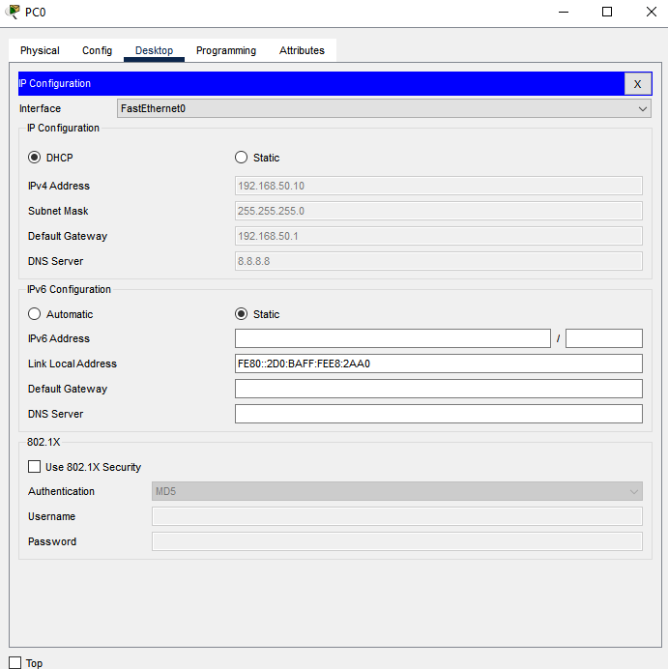

PC1:

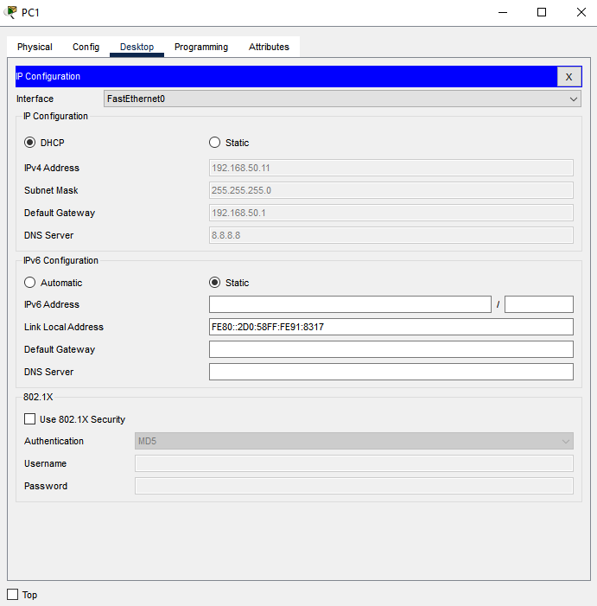

PC2:

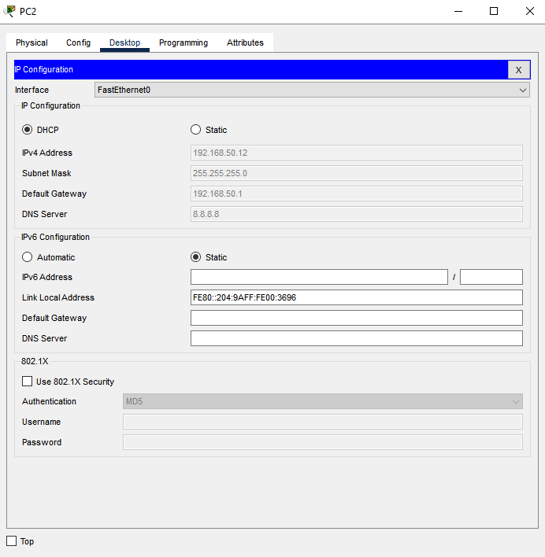

**Task 3:**

Set up a DNS server and test domain name resolution.

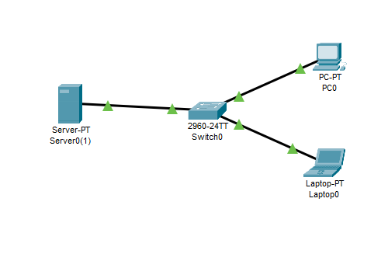

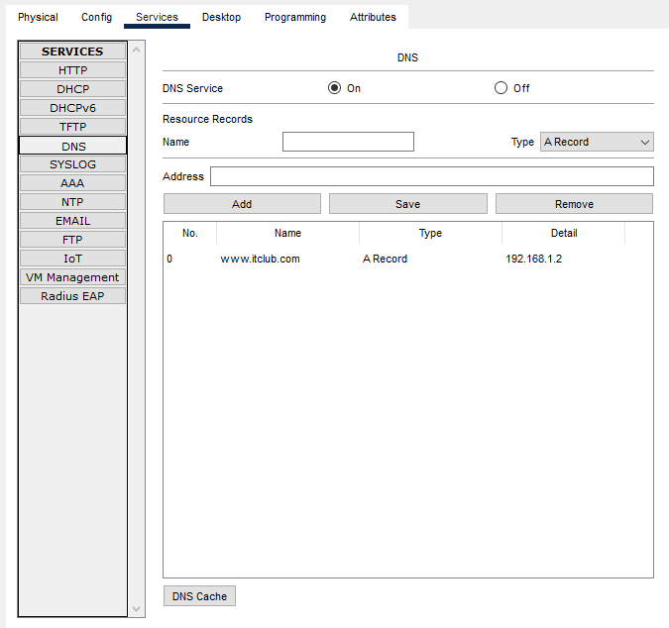

**Result:**

